**Report of project**

Project failed

This project is built based on the book: ***Programming the semantic web*** by Toby Segaran. There are several ways to build an application as it is introduced in the book for this project. One can used Jena API and bring in RDF files to search for a criteria that one desires. The book introduces Sesame and other components to build this application.

I did not try Jena, however, it can be a better way to use it if I had more time. other difficulties that I had were installing the packages for python to run to codes and making connection to HMLT file to display the result of the searching. It was consuming time for me. Anyway, this project was a good way to learn and take advantages of semantic data, bring data into a standard form and display it in searching application.

Requirements:

Install these toolkits:

pip install RDFLib

pip install metaweb

pip install mako

pip install cherrypy

Go to this website to download sesame library and build path in Java to add this library to Java library. <http://sourceforge.net/projects/sesame/files/Sesame%202/>

Jetty downloads: <http://download.eclipse.org/jetty/>

Download pysesame and copy the files in the folder to python lib and Script

<http://projects.semwebcentral.org/frs/?group_id=16>

Following the proposal, I carried out the steps to build an application base on Java and python. I was able to build rdf and load to sesame.

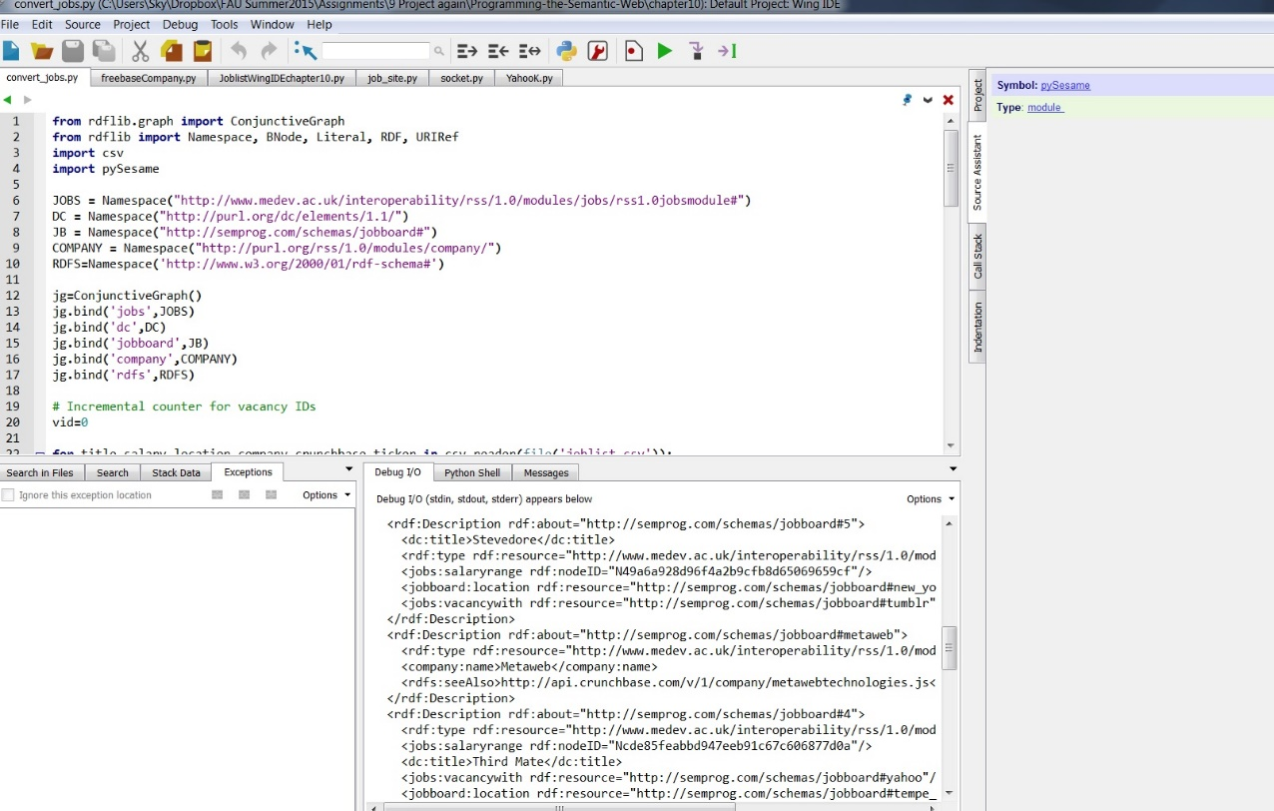

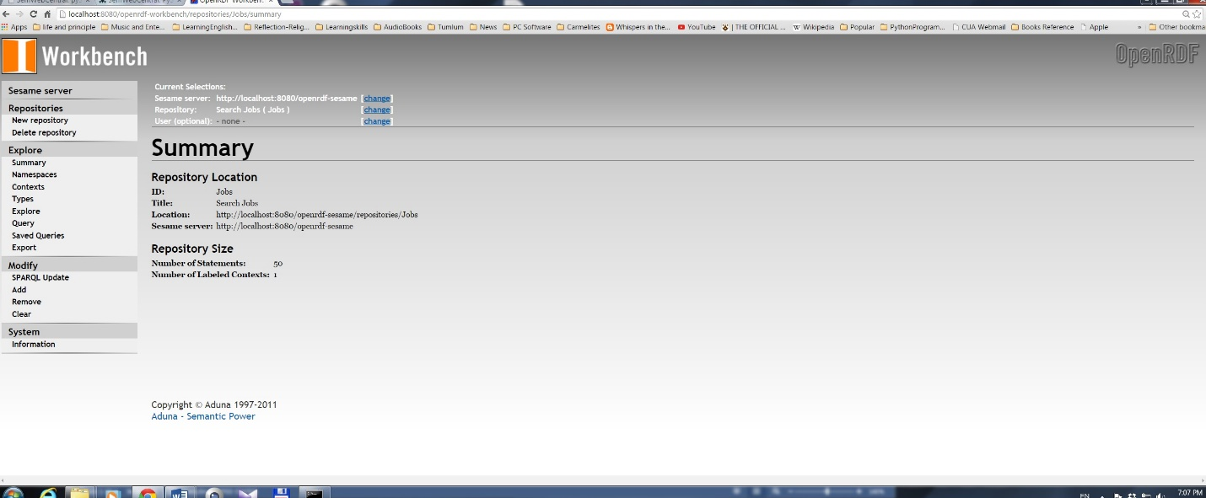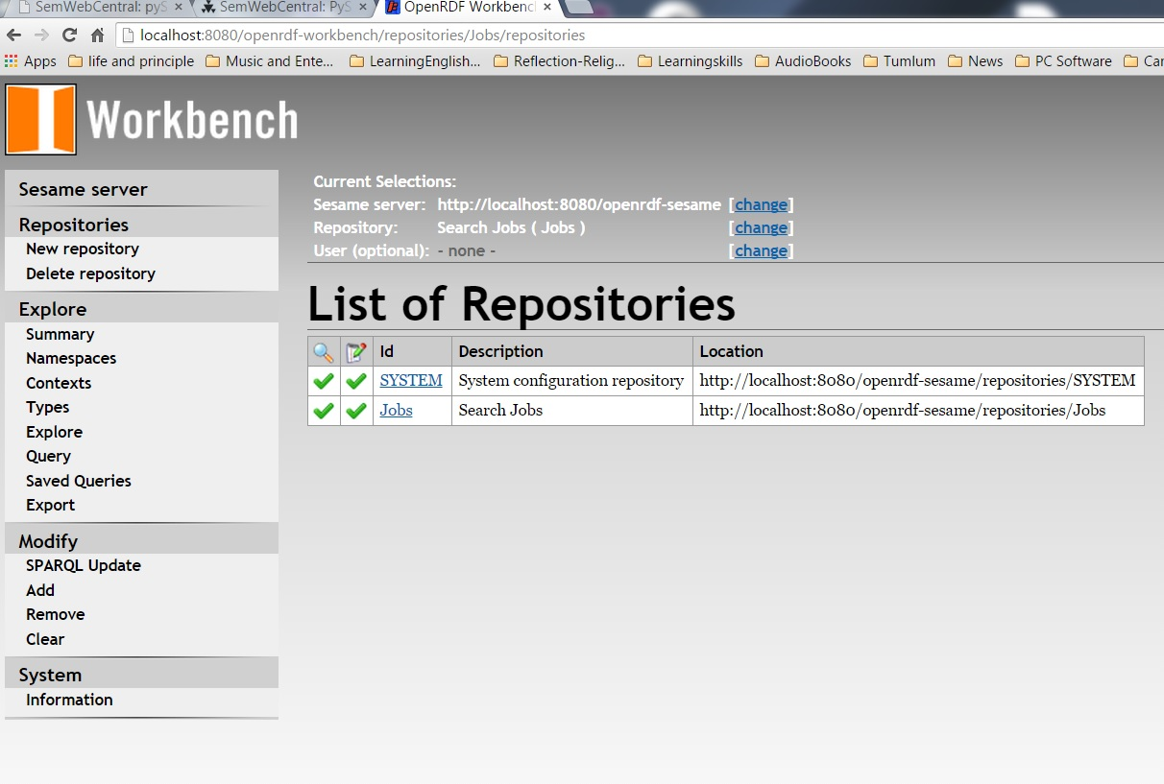

But there is ***an error of socket*** when I tried to display a result of searching:

